1. **Goal**
   1. The high level goal for this sprint is to complete the polished version of the app and potentially include the recommender for a bonus feature.
2. **Task Listing**
   1. As a user I would like to be able to receive notifications from the app[8]
      1. Create a homepage for when booting the app for the first time where it can ask for the notification privileges. (3 hours)
      2. Link the people the user is following to the notifications. This means that when someone who a user is following posts, then the notification will go out. (2 hours)
   2. As a user, I would like to see a dish of the day at the top of my home page. [5]
      1. Create an endpoint to fetch the dish (1 hour).
      2. Create the components to house this on the home page. (2 hour)
      3. Add the component to the home page (2 hour)
      4. Link the component and the endpoint (1 hour)
   3. As a user, I would like to be able to access a recommended foods, “new eats”, within the explore page [21]
      1. Set Up an endpoint that once called will feed the data for the user into the GPT wrapper and query it for new recommended foods. This will then return one new dish for the user. (6 hours)
      2. Create the component for this recommended dish slot. (2 hours)
      3. Add the component to the explore page and stylize it. (3 hours)
      4. Link the endpoint and the component and test. (3 hours)
   4. As a user I would like to be able have a welcome page to set my initial preferences [12]
      1. Make the page and stylize it (4 hours)
      2. Make the endpoint for setting the initial information for the user (2 hours)
      3. Link the front end user customization to the backend (2 hours)
3. **Team Roles**
   1. Luca Schram: Scrum Master
   2. Keaton Shawhan: Product Owner
   3. Nico Vitagliano: Developer
   4. Zoe Feller: Developer
   5. Jake Gurien: Developer
4. **Task Assignment**
   1. Luca Schram
      1. Create the endpoints for the notifications. (1 hour)
      2. Create the tests for the endpoint. (2 hours)
      3. Create the endpoint for the GPT worker. (4 hours)
      4. Create the tests for the GPT recommendation endpoint. (2 hours)
   2. Keaton Shawhan
      1. Make the endpoints for the dish sponsor slot. (1 hour)
      2. Make the component for the sponsor slot (2 hours)
      3. Work on the welcome page context and endpoint (6 hours)
   3. Nico Vitagliano
      1. Make the dish of the day component (1 hour)
      2. Insert the component and restyle (2 hours)
      3. Connect the end point to it (2 hours)
      4. Fix the like counter for the posts on all pages (2 hours)
      5. Link the achievements to the actual post count on the profile page (2 hours)
   4. Jake Gurien
      1. Style the welcome page (4 hours)
      2. Setup asking for the notifications privileges and setup the notifications on previous front end calls (4 hours)
   5. Zoe Feller
      1. Setup the database feed to gpt wrapper (4 hours)
      2. Run prompt tests on the recommender (4 hours)
5. **Burnup Chart**

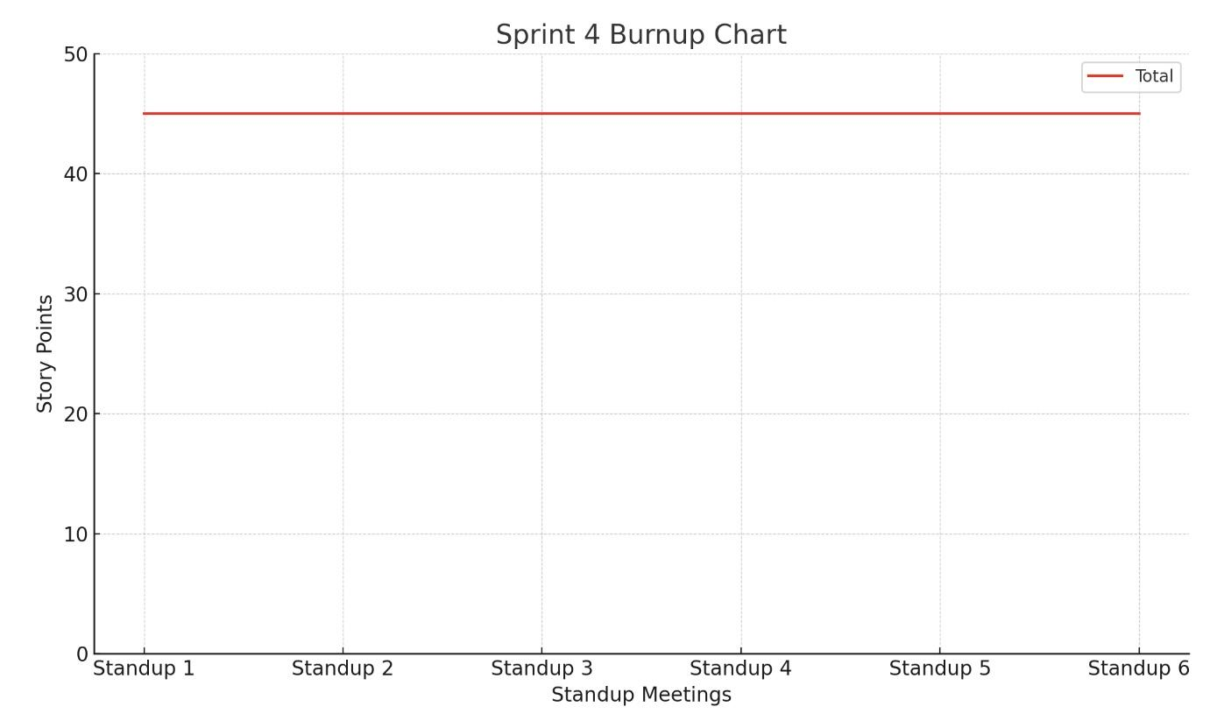

1. **Scrum Times**
   1. Week 8 (Sprint Begins Wednesday)
      1. Wednesday 11/20/24 - 11:00 A.M.
      2. Thursday 11/21/24 - 3:00 P.M.
      3. Friday 11/22/24 - 11:00 A.M.
   2. Week 9
      1. Monday 11/25/24 - 11:00 A.M. - **TA Meeting**
      2. Wednesday 11/27/24 - 11:00 A.M.
      3. Friday 11/29/24 - 11:30 A.M.
   3. Week 10 (Half Sprint)
      1. Monday 12/2/24 - 11:00 A.M. - **TA Meeting**
      2. Tuesday 12/4/24 - 1:30 P.M. - **End of Sprint 4**